Project Design Phase
Solution Architecture
Date | 17 September 2026
Team ID | Individual project
Project Name | Software Installation Request Automation
Maximum Marks | 4 Marks
Solution Architecture:
Solution architecture defines how the business problem is translated into a structured technology solution. For the ServiceNow Employee Issue Management project, the architecture connects the employee-facing Service Portal with a Record Producer and a custom Employee Issue table so that workplace-related issues can be submitted, validated, categorized, assigned, prioritized, and tracked in a controlled process.
The architecture describes the major components, their relationships, the flow of issue information, and the responsibilities of employees, support teams, and the ServiceNow platform. It bridges the problem of informal and inconsistent issue reporting with a structured ServiceNow-based issue-management solution.
Architecture Goals for the Project:
• Provide a standard Service Portal entry point for employees to raise workplace-related issues.
• Use a Record Producer to provide a simplified employee-facing issue submission form.
• Automatically create an Employee Issue record in the custom table when an issue is submitted.
• Validate submitted information using Client Scripts, UI Policies, Data Policies, and server-side validation.
• Implement field dependencies so that related fields and available options respond appropriately to employee selections.
• Apply business logic to support issue categorization, prioritization, and assignment.
• Provide a centralized location for support teams to manage and update employee issues.
• Allow employees and support teams to track the status and resolution of submitted issues.

Solution Architecture Diagram:
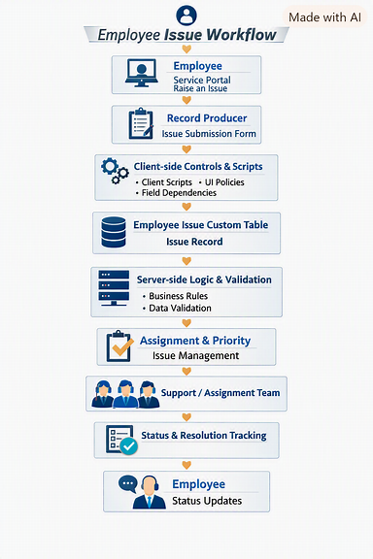
Figure 1: Architecture and data flow of the Software Installation Request Automation solution
Architecture Components:
Component | Role in the Solution
Employee / User | Initiates an employee issue through the Service Portal and can provide the required issue details. The employee can also track the status of the submitted issue.
Service Portal | Provides the employee-facing interface through which users can access the issue-raising functionality and submit workplace-related concerns.
Raise an Employee Issue | Provides the entry point for employees to initiate the issue submission process through the Service Portal.
Record Producer | Collects employee issue information and creates a corresponding record in the custom Employee Issue table without exposing the backend table form directly to employees.
Client Scripts | Perform client-side validation and dynamic form behavior based on user input and selected field values.
UI Policies | Control field visibility, mandatory states, and read-only behavior according to configured conditions.
Field Dependencies | Establish relationships between fields so that available selections can depend on previously selected values.
Data Policies | Enforce required data conditions and help maintain data consistency when records are created or updated.
Employee Issue Custom Table | Stores the submitted employee issue information in a centralized ServiceNow table for further processing and management.
Business Rules | Execute server-side business logic to validate, process, or modify issue records when defined conditions are met.
Assignment Logic | Determines or supports routing of issues to the appropriate support or assignment group based on issue information.
Priority Logic | Supports determination of issue priority based on configured business conditions and issue characteristics.
Support / Assignment Team | Reviews assigned issues, performs the required actions, updates issue information, and works toward resolution.
Issue Status Tracking | Maintains the current state of the issue so that employees and support teams can understand the progress from submission to resolution.
ServiceNow Platform | Provides the underlying platform for storing issue records, executing client/server-side logic, managing configurations, and supporting the complete issue-management process.
Data and Control Flow:
1. The employee opens the Service Portal and selects the Raise an Employee Issue functionality.
2. The Record Producer displays the employee issue submission form and collects the required information such as issue category, issue details, and other configured fields.
3. As the employee enters information, Client Scripts, UI Policies, and field dependencies apply the configured client-side behavior. Required fields and appropriate field values are enforced.
4. When the employee submits the form, the Record Producer creates an Employee Issue record in the custom Employee Issue table.
5. Server-side processing is performed using configured Business Rules and Data Policies to validate and process the submitted record.
6. Based on the configured business logic, the issue can be categorized, prioritized, and assigned to the appropriate support or assignment group.
7. The assigned support team reviews the issue, performs the required work, and updates the issue status throughout its lifecycle.
8. The employee can use the ServiceNow environment to track the progress and status of the submitted issue until it reaches resolution.
9. Once the issue is resolved, the final issue information remains stored in the Employee Issue custom table, providing a centralized record for tracking and future reference.

Architecture Benefits:
• Provides a standardized employee-facing process for raising workplace-related issues.
• Separates the employee submission interface from the backend issue-management table.
• Reduces inconsistent data collection through structured fields and validation.
• Uses Record Producer functionality to simplify issue creation from the Service Portal.
• Improves data quality through Client Scripts, UI Policies, Data Policies, and Business Rules.
• Supports consistent issue categorization, prioritization, and assignment.
• Centralizes employee issues within a dedicated ServiceNow table.
• Provides better visibility into the status and resolution of submitted issues.
• Reduces manual coordination and informal communication between employees and support teams.
• Provides an extensible architecture that can later support notifications, SLAs, Flow Designer/Workflow Studio automation, dashboards, reports, approval steps, and additional assignment rules.

